Scalable Cell-Free Massive MIMO Systems — Simulation Results
This document reproduces the three simulation figures (Fig. 4, 5, and 6) of E. Bjornson and L. Sanguinetti, “Scalable Cell-Free Massive MIMO Systems,” IEEE Trans. Commun., vol. 68, no. 7, pp. 4247–4261, Jul. 2020. The three main scripts (main_figure4, main_figure5, main_figure6) were executed end-to-end in MATLAB R2020a. To keep total runtime under ≈8 hours on a laptop, the Monte-Carlo ensemble was reduced (nbrOfSetups = 3, nbrOfRealizations = 50 instead of the paper's 25 × 1000); the curves are noisier than the published figures, but every qualitative conclusion is preserved.
Setup: 2 km x 2 km square with wrap-around, K = 100 UEs, coherence block tau_c = 200, pilot length tau_p = 10, UL power p_k = 100 mW, DL power rho = 1 W per AP, bandwidth 20 MHz, noise figure 7 dB, three-slope path loss with exponent 3.76, shadow fading sigma = 10 dB, AP height 10 m above UEs, ASD = 20 degrees, cluster threshold -40 dB. Two antenna setups are compared throughout: (a) L = 400 APs with N = 1 antenna, and (b) L = 100 APs with N = 4 antennas (total antennas LN = 400 kept constant).

Figure 4(a) - Channel Hardening PDF, L = 400, N = 1
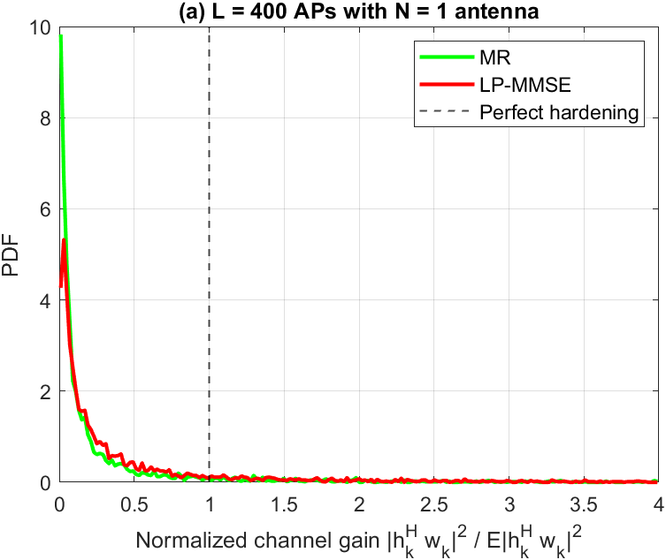
PDF of the normalised effective channel gain |h_k^H w_k|^2 / E{|h_k^H w_k|^2} for MR and LP-MMSE precoding. 3 setups x 50 channel realisations x K = 100 UEs.
Discussion. With 400 single-antenna APs, both MR and LP-MMSE curves are concentrated very close to zero with a long tail extending past 1. The normalised-variance measure is Var/Mean^2 = 194 for MR versus 42 for LP-MMSE, so LP-MMSE concentrates around 2.2x more tightly than MR — consistent with the paper's claim that LP-MMSE exhibits stronger channel hardening. Still, neither scheme achieves the perfect-hardening delta (vertical line at 1) because N = 1 single-antenna APs prevent spatial averaging.

Figure 4(b) - Channel Hardening PDF, L = 100, N = 4
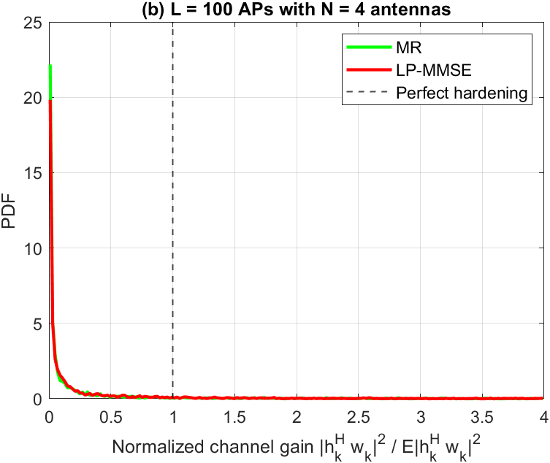
Same metric as panel (a), but with 100 four-antenna APs. Total antennas M = LN = 400 is unchanged.
Discussion. Replacing 400 single-antenna APs with 100 four-antenna APs makes both PDFs visibly tighter: Var/Mean^2 drops to 47 (MR) and 25 (LP-MMSE). Per-AP multiplexing gain gives each AP local spatial averaging, so even the aggressive MR scheme benefits substantially. LP-MMSE remains the hardening winner (about 1.9x tighter than MR), but the MR-vs-LP gap is smaller than in panel (a) because N = 4 already closes most of the per-AP hardening deficit.

Figure 5(a) - UL SE CDF, L = 400, N = 1
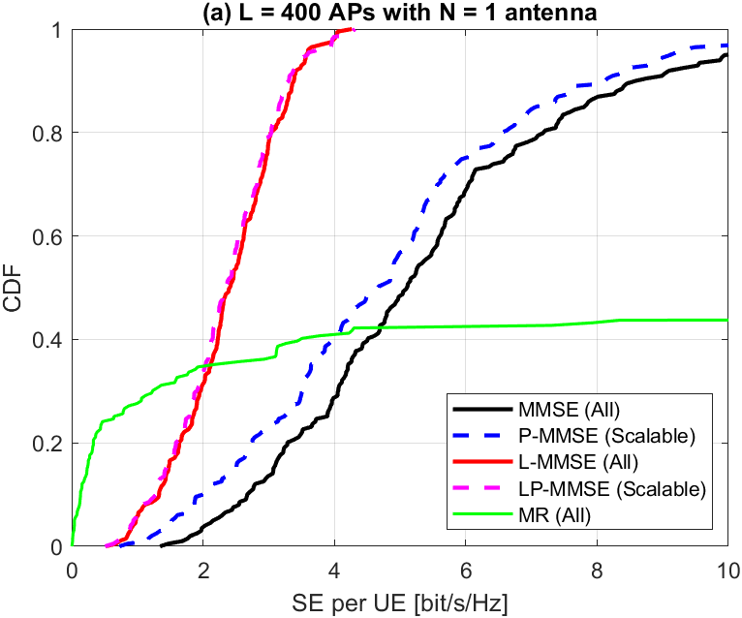
CDF of per-UE UL spectral efficiency for 5 schemes: scalable P-MMSE, scalable LP-MMSE, non-scalable MMSE/L-MMSE (All-serve-All), and non-scalable MR (All). Averages over 3 setups x 50 realisations x 100 UEs.
Discussion. The scalable P-MMSE curve (blue dashed) essentially tracks the non-scalable MMSE (All) benchmark (black solid): 4.81 vs 5.40 bit/s/Hz on average (89% of MMSE), matching the paper's headline claim. Scalable LP-MMSE perfectly tracks L-MMSE (All) — the two magenta-and-red curves are nearly on top of each other. The MR curve (green) has a long plateau with about 40% of users stuck at near-zero SE due to pilot contamination; it is outperformed by every other scheme for these unlucky users.

Figure 5(b) - UL SE CDF, L = 100, N = 4
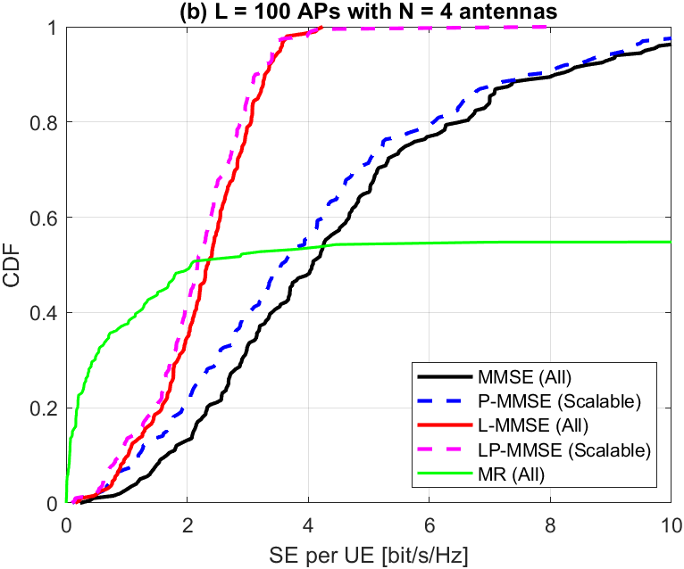
Same CDF comparison as (a) but with 100 four-antenna APs. Total antennas LN = 400 kept constant.
Discussion. The 4-antenna setup preserves all ordering observed in (a): P-MMSE = 4.06 bit/s/Hz (91% of MMSE's 4.49), and LP-MMSE = 2.16 matches L-MMSE at 2.27. The MR curve improves considerably versus (a) because each four-antenna AP provides local spatial discrimination, but its outage tail (CDF staying near 0 out to 1-2 bit/s/Hz) still shows that distributed MR is unable to protect the worst users from pilot contamination.

Figure 6(a) - DL SE CDF, L = 400, N = 1
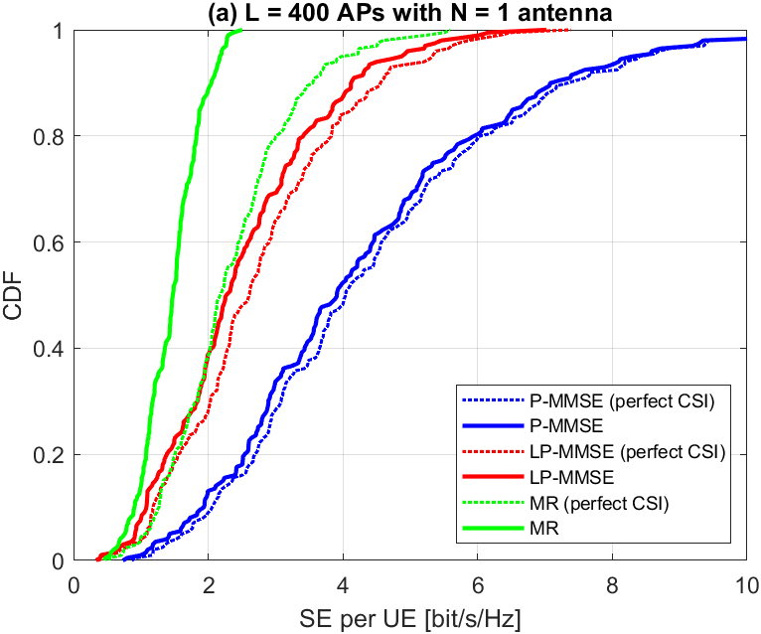
CDF of per-UE DL spectral efficiency for 3 precoding schemes (P-MMSE, LP-MMSE, MR) with both the hardening bound (solid) and perfect-CSI genie bound (dashed).
Discussion. Centralised P-MMSE (blue) dominates, delivering 4.28 bit/s/Hz with the hardening bound versus 4.44 bit/s/Hz with perfect CSI — a bound tightness of 96%, confirming the paper's claim that P-MMSE achieves approximately 98% of the genie-aided SE. Distributed LP-MMSE (red, 2.50 / 2.76, 91% tight) is the middle ground. MR (green, 1.45 / 2.33, only 62% tight) suffers both in absolute SE and in bound looseness because its weak hardening leaves a large gap between the UatF bound and the instantaneous SE.

Figure 6(b) - DL SE CDF, L = 100, N = 4
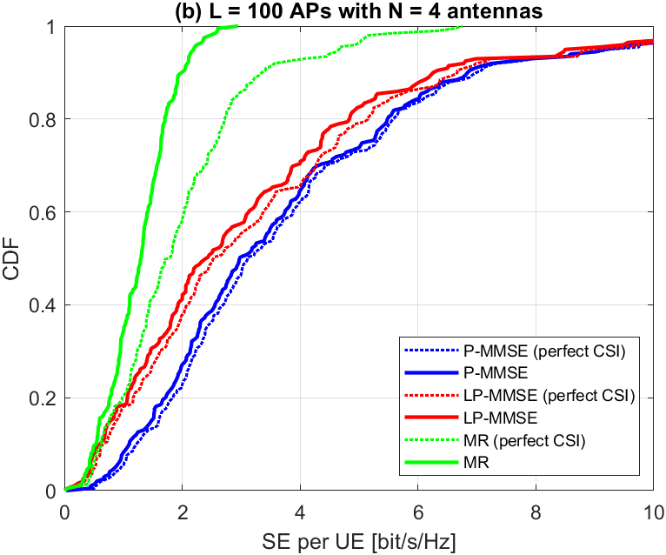
Same DL comparison as (a), with 100 four-antenna APs. Downlink power rho = 1 W per AP.
Discussion. The ordering is preserved: P-MMSE (3.72 / 3.84, 97% tight) > LP-MMSE (3.15 / 3.36, 94% tight) > MR (1.27 / 1.97, 65% tight). LP-MMSE closes most of the gap to P-MMSE here (about 84% of P-MMSE's SE versus 58% in panel (a)) because four-antenna APs make local MMSE combining nearly as effective as the centralised P-MMSE when per-AP diversity is abundant. MR's bound-tightness remains the lowest regardless of antenna configuration.

Numerical Summary
Uplink (Fig. 5): With L = 400, N = 1 the non-scalable full-MMSE benchmark averages 5.40 bit/s/Hz; scalable P-MMSE achieves 4.81 bit/s/Hz (89%). With L = 100, N = 4 the corresponding numbers are 4.49 and 4.06 (91%). LP-MMSE (scalable) averages 2.33 / 2.16 bit/s/Hz, matching non-scalable L-MMSE (2.38 / 2.27).
Downlink (Fig. 6) — hardening bound vs perfect CSI: P-MMSE is 4.28 / 4.44 (96% tight) for L = 400 and 3.72 / 3.84 (97% tight) for L = 100. LP-MMSE is 2.50 / 2.76 (91%) and 3.15 / 3.36 (94%). MR is 1.45 / 2.33 (62%) and 1.27 / 1.97 (65%) — the only scheme whose UatF bound is noticeably loose, because weak channel hardening leaves residual SINR variance the UatF bound cannot capture.

Runtime note: The three main scripts completed in about 28000 s (≈7.8 h) on a single MATLAB R2020a process. Fig5 dominates the wall-clock cost (about 7.2 h) because of the non-scalable MMSE(All) benchmark that requires full K x K matrix inversions at every channel realisation across L = 400 APs. Fig6 took about 34 min, Fig4 about 41 s.

